2025 IACC Conference – Registration instructions

Like in year’s past, AWC is handling our registration process, so we’ve included some tips that should help you navigate the process. We hope that this extra information will assist you in getting properly registered.

When you click this link: IACC Conference 2025 you will be taken to an AWC page with information about the IACC Conference 2025. There will be a yellow “Login to Register” button on the right side of the page.

For exhibit registration, click this link: IACC Conference 2025 – Exhibit Registration
(registration instructions will be the same as for the individual registrations).

To register
Once you click the “Register” button”, you will be prompted to log in with your AWC user name and password. Once logged in, follow the prompts to register yourself or another person from your organization.

If you did this last year, but don’t recall your username or password, just follow the prompts to retrieve your username and/or to set a new password.

If this is your first time registering for the conference, you can sign up to create a new user profile by clicking “Sign up”.
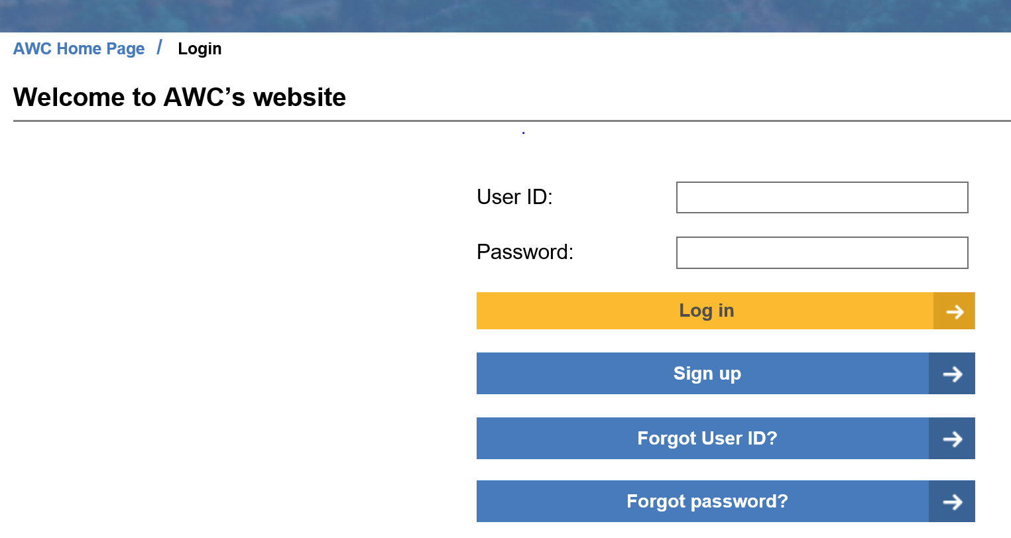

You will be prompted to create a username/password and to enter your organization’s name. If your organization is in the AWC data base the name will appear in a drop down. The list is populated with all cities, towns, most state agencies, etc., but does not have all districts, private companies, and others in it. If your organization does NOT show up in the dropdown box, you must contact awctechsupport@awcnet.org with your company name, address, and phone number. You will be able to continue with your registration AFTER your company is added to the AWC database.

Continue onto the next page…

FAQ’s
Can I pay with a credit card?
If you pay with a credit card, your billing address for the card must match your address in the registration process. If it does not, add a new address that matches, otherwise your payment will be declined. You also have the option to ask for invoice billing.

Will I receive a confirmation of my registration?
You will be able to email the registration confirmation to your email account or to multiple email accounts.

AWC staff is committed to helping you with any outstanding issues…just call or email if you have registration issues.

Troubleshooting
If at any time during the registration process you are redirected back to the AWC home page, click on the Events & Education tab to go to “Upcoming AWC events” page. You can then scroll to find the IACC Conference registration link.

To get back to the IACC Conference home page, you can click on the link provided on the registration main page: (highlighted)

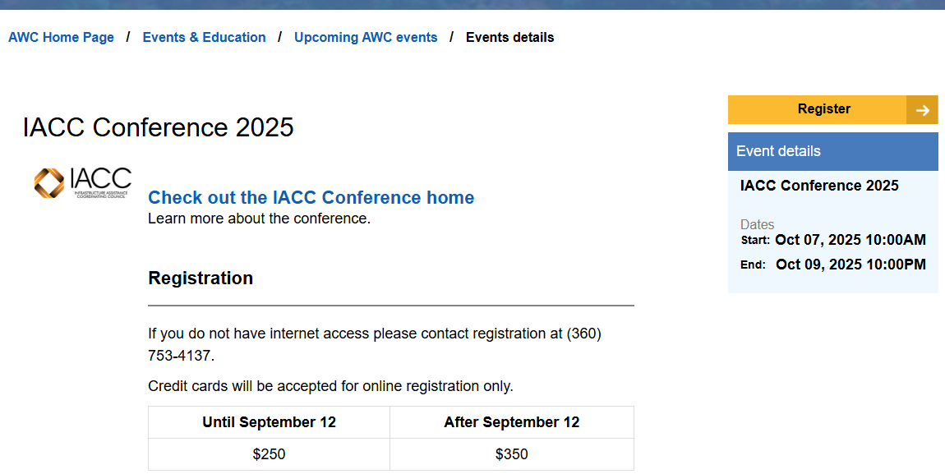

**If you get stuck in your cart, click on the IACC Conference 2024 hyperlink (in the cart window) to return to the main registration page.

For further assistance, please contact:

AWC Registration
360-753-4137
Registration@awcnet.org

Scholarships
If you are requesting a scholarship, you must enter one of the following codes during the registration process:
- AWC Small City Scholarship: 2025ICSCS
- RMSA Scholarship: Please contact RMSA staff at RMSA@awcnet.org.
- IACC Scholarship: Please contact Brianna Morin at (360) 753-4137 or briannam@awcnet.org to request an IACC scholarship.

